**Smart E-Health Prediction**

Abstract: This project aims to provide a web platform to predict the occurrences of disease on the basis of various symptoms. The user can select various symptoms and can find the diseases and consult to the doctor online.

Project Scope

* + The disease prediction system have three users such as doctor, patient and admin.
  + Each user of the system are authenticated by the system.
  + There is a role based access to the system.
  + The system allows the patient to give symptoms and according to those symptoms the system will predict a disease.
  + The system suggests doctors for predicted diseases.
  + The system allows online consultation for patients.
  + The system helps the patients to consult the doctor at their convenience by sitting at home.

Technology Used

Front end: HTML, CSS, Bootstrap, Javascript, Jquery

Back end: Django (python based web framework)

Data collection

Data collection has been done from the internet to identify the disease here the real symptoms of the disease are collected i.e. no dummy values are entered.

The symptoms of the disease are collected from kaggle.com and different health related websites. This csv file contains 5000 rows of record of the patients with their symptoms (132 types of different symptoms) and their corresponding disease (40 class of general disease).

Architecture of the System

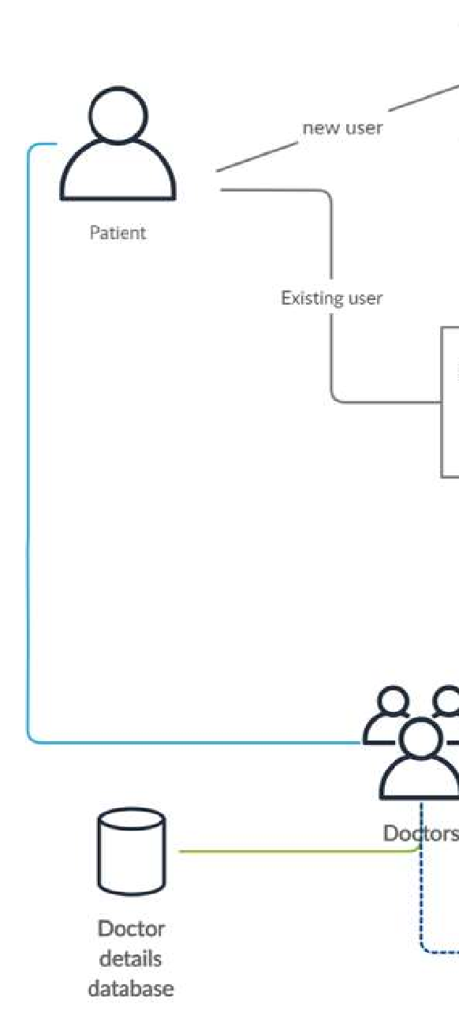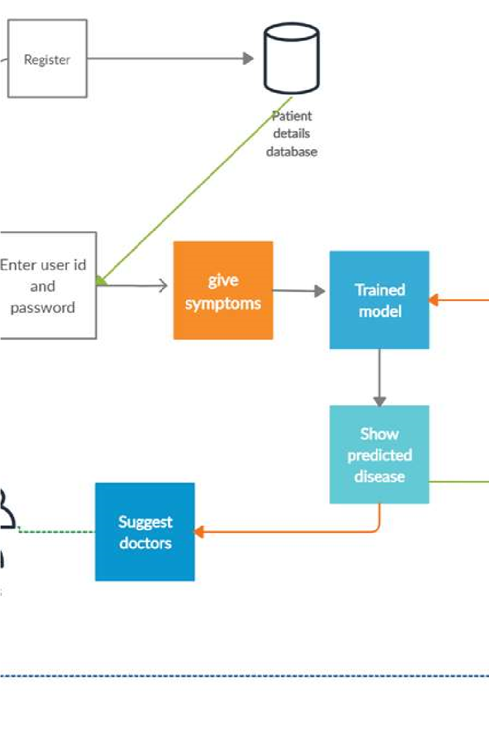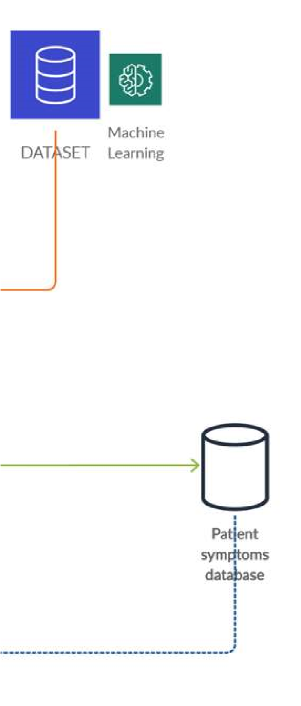

Git Repository Link:

https://github.com/Ajmi-A/E-Health-prediction.git